Land Use and Ionic Contamination as Drivers of Leaf Litter
Decomposition in Urban and Agricultural Streams:
Evidence from Two German Catchments
[Author Names]¹, [Co-Author]², [Supervisor]¹
¹ [University/Institute], [City, Germany] | ² [Institute 2], [City, Germany]
Manuscript received: March 2025 | Correspondence: [corresponding.author@institution.de]

ABSTRACT
Leaf litter decomposition is a critical ecosystem function in streams, mediated by both microbial communities and invertebrate shredders. Yet our understanding of how land use type—urban versus agricultural—shapes decomposition rates and associated drivers remains incomplete. We deployed alder leaf litter (Alnus glutinosa) in fine mesh (0.5 mm, microbial only) and coarse mesh (10 mm, microbial + invertebrate) bags across 23 sites in the Boye Stream (urban/industrial catchment, Ruhr region) and 21 sites in the Kinzig Stream (agricultural/rural catchment) in March 2025. Decomposition rates were quantified as Decomposed Substrate Mass (DSM; % mass loss per degree-day). We tested four site-specific hypotheses per stream to identify the primary environmental drivers of decomposition. In the Boye Stream, conductivity emerged as the primary negative predictor of microbial DSM (Pearson r = −0.459, p = 0.028), consistent with ionic suppression of fungal decomposers in urbanised streams. In the Kinzig Stream, agricultural land use proportion was the dominant positive predictor of microbial DSM (r = +0.738, p = 0.0002), reflecting nutrient-stimulated microbial activity. In both streams, coarse mesh DSM significantly exceeded fine mesh DSM (Boye: 3.04×, Kinzig: 3.62×; both p < 0.001), demonstrating critical invertebrate shredder contributions regardless of catchment type. Metal contamination (Zn, Cu) did not significantly predict decomposition rates, likely because concentrations remained below functionally relevant toxicity thresholds. These findings reveal that the primary controls on stream ecosystem function differ fundamentally between urban and agricultural catchments, with implications for multi-stressor assessment frameworks and bioassessment strategies.

Keywords: leaf decomposition; DSM; coarse mesh; fine mesh; shredder invertebrates; land use; urban streams; agricultural streams; ecosystem function; multiple stressors

1. INTRODUCTION
Stream ecosystems are critical components of global biogeochemical cycles, processing substantial quantities of allochthonous organic matter—particularly leaf litter from riparian vegetation. Leaf litter decomposition is widely used as an integrative functional indicator of stream ecosystem health (Gessner & Chauvet, 2002; Woodward et al., 2012), as it integrates the activity of both microbial decomposers (bacteria, aquatic hyphomycetes) and invertebrate shredders (Gammarus, Trichoptera) into a single, ecologically meaningful metric.
The rate of leaf decomposition is governed by a complex interaction of substrate quality, water chemistry, temperature, and the composition of the decomposer community (Lecerf & Richardson, 2010). In human-impacted catchments, these drivers are modified by land use change, which introduces multiple simultaneous stressors: nutrient enrichment in agricultural catchments, and ionic contamination, metal pollution, and reduced biodiversity in urban and industrial streams (Schreiner et al., 2023; Bundschuh et al., 2019). The relative importance of these stressors for stream ecosystem function, and whether they act additively, synergistically or antagonistically, is not yet fully understood.
Schreiner et al. (2023) demonstrated that leaf decomposition rates are negatively associated with multiple stressor indices in German streams, particularly combinations of ionic contamination, nutrient loading, and toxicant exposure. However, individual catchment-level studies that attribute decomposition variation to specific land use categories and their associated chemical signatures—in isolation and within a consistent spatial framework—remain valuable for mechanistic interpretation.
This study addresses this gap using a paired-catchment approach, comparing leaf decomposition across two German stream systems representing contrasting land use contexts: the Boye Stream (urban/industrial catchment in the Ruhr region) and the Kinzig Stream (predominantly agricultural catchment in Hesse). We tested four mechanistic hypotheses for each stream concerning the role of conductivity, land use intensity, invertebrate shredder abundance, and metal contamination as drivers of decomposition rates. The normalised DSM metric (Schreiner et al., 2023) was used to account for temperature differences between sites and deployment periods.

1.1 Research Hypotheses
Boye Stream:
- H1: Higher electrical conductivity (ionic load) negatively predicts fine mesh (microbial) decomposition rates.
- H2: Higher urban land use percentage is associated with reduced leaf decomposition rates, reflecting multi-stressor suppression of decomposers.
- H3: Higher Gammarus shredder abundance drives significantly higher coarse mesh decomposition rates, and coarse mesh DSM significantly exceeds fine mesh DSM.
- H4: Higher Zn and Cu concentrations reduce microbial leaf decomposition rates through fungal toxicity.
Kinzig Stream:
- H1: Higher nitrate concentrations (from agricultural runoff) are positively correlated with fine mesh DSM through nutrient-stimulated microbial activity.
- H2: Higher agricultural land use percentage is positively associated with leaf decomposition rates due to enhanced nutrient loading.
- H3: Coarse mesh DSM significantly exceeds fine mesh DSM, confirming invertebrate shredder contribution to decomposition.
- H4: Higher conductivity (co-varying with nutrient enrichment) is positively associated with leaf decomposition rates.

2. MATERIALS AND METHODS
2.1 Study Sites
The Boye Stream drains an urbanised catchment (total area: ~100–5,300 km² per sub-catchment) in the Ruhr region of North Rhine-Westphalia, Germany. Twenty-three sites were selected spanning a gradient of urban (0–98 %), agricultural, and industrial land use, reflecting the diverse legacy of heavy industry in the region. Mean catchment conductivity was 854.8 µS/cm, and mean urban land use was 41.5 %.
The Kinzig Stream drains an agricultural catchment in Hesse, Germany. Twenty-one sites were selected across a predominantly agricultural gradient (mean: 52.1 % agricultural land use; range: 13.6–71.2 %). Mean conductivity was 330.7 µS/cm. Both streams drain watersheds with contrasting geology, hydrology, and anthropogenic impact, making them ideal for paired-catchment comparisons.
2.2 Leaf Litter Bag Deployment
Air-dried alder leaves (Alnus glutinosa) were packed into fine mesh (0.5 mm, ~3 g initial mass) and coarse mesh (10 mm, ~3 g initial mass) bags, with three replicates per bag type per site. Bags were deployed between 4–11 March 2025 and retrieved after approximately 15 days (incubation range: 13–19 days). Incubation was conducted at in-situ water temperatures, which were recorded using data loggers at Boye sites and from water chemistry measurements at Kinzig sites.
2.3 Laboratory Analysis
Retrieved leaf material was dried at 60°C for 48 h to obtain dry mass, then combusted at 500°C for 4 h to determine ash mass. Ash-Free Dry Mass (AFDM) was calculated as AFDM = mass(60°C) − mass(500°C). Leaf disks removed during retrieval for companion analyses were corrected using a standard disk weight of 12 mg per disk. Transport controls (n = 9 per catchment) travelled with field teams to quantify handling and transport losses, enabling conversion of initial air-dry mass to theoretical AFDM start.
2.4 DSM Calculation
Decomposed Substrate Mass (DSM) was calculated following Schreiner et al. (2023):
DSM = [(AFDM_start − AFDM_end) / AFDM_start] ÷ [mean temperature × incubation days] × 100
DSM values ≤ 0 were excluded. All DSM values are reported in units of % organic mass lost per degree-day (% °C⁻¹ day⁻¹).
2.5 Environmental Variables
Water chemistry was measured at each site during bag retrieval including pH, electrical conductivity, dissolved oxygen, temperature, nutrients (NO₂, NO₃, NH₄, ortho-PO₄, total PO₄, total N), major ions (Ca, Mg, Na, K, Cl, SO₄, CO₃, HCO₃), and metals (Cd, Cu, Fe, Ni, Pb, Zn) via ICP-MS. Substrate composition was estimated visually using the LAWA substrate classification. Land use data (GIS-derived percentages of agricultural, urban, industrial, and rural land) were extracted for each catchment. Macroinvertebrate assemblages were sampled using a standardised kick-net protocol and identified to genus or species level.
2.6 Statistical Analysis
Site-level DSM means were computed from three replicates per bag type. Pearson correlation coefficients were calculated between DSM and each environmental predictor. Welch's two-sample t-tests compared fine and coarse mesh DSM within each stream. Multiple regression models were fitted to identify independent predictors. All skewed variables (metals, Gammarus abundance) were log₁₀(x+1) transformed prior to correlation analysis. Statistical significance was assessed at α = 0.05. All analyses were conducted in R v4.3 (R Core Team, 2024) using the packages dplyr, ggplot2, ggeffects, and stabs.

3. RESULTS
3.1 Overall Decomposition Rates
Leaf decomposition differed substantially between streams and bag types (Table 1). Mean fine mesh DSM was 0.173 ± 0.035 %/DD in Boye and 0.100 ± 0.035 %/DD in Kinzig. Mean coarse mesh DSM was 0.526 ± 0.205 %/DD in Boye and 0.360 ± 0.135 %/DD in Kinzig. In both streams, coarse mesh DSM significantly exceeded fine mesh DSM: Boye by a factor of 3.04 (t = 13.95, df = 125, p < 0.001) and Kinzig by 3.62 (t = 13.60, df = 103, p < 0.001), demonstrating substantial invertebrate shredder contributions to total decomposition at all sites (Figure 1).

Stream | Bag Type | n | Mean DSM | ± SD | Min | Max
Boye | Fine mesh | 64 | 0.1730 | 0.0349 | 0.0824 | 0.2718
Boye | Coarse mesh | 68 | 0.5258 | 0.2054 | 0.0547 | 0.9496
Kinzig | Fine mesh | 58 | 0.0996 | 0.0348 | 0.0314 | 0.1973
Kinzig | Coarse mesh | 53 | 0.3600 | 0.1354 | 0.1375 | 0.6667
Table 1. Summary of DSM by stream and bag type. DSM units = % organic mass loss per degree-day (%/DD).

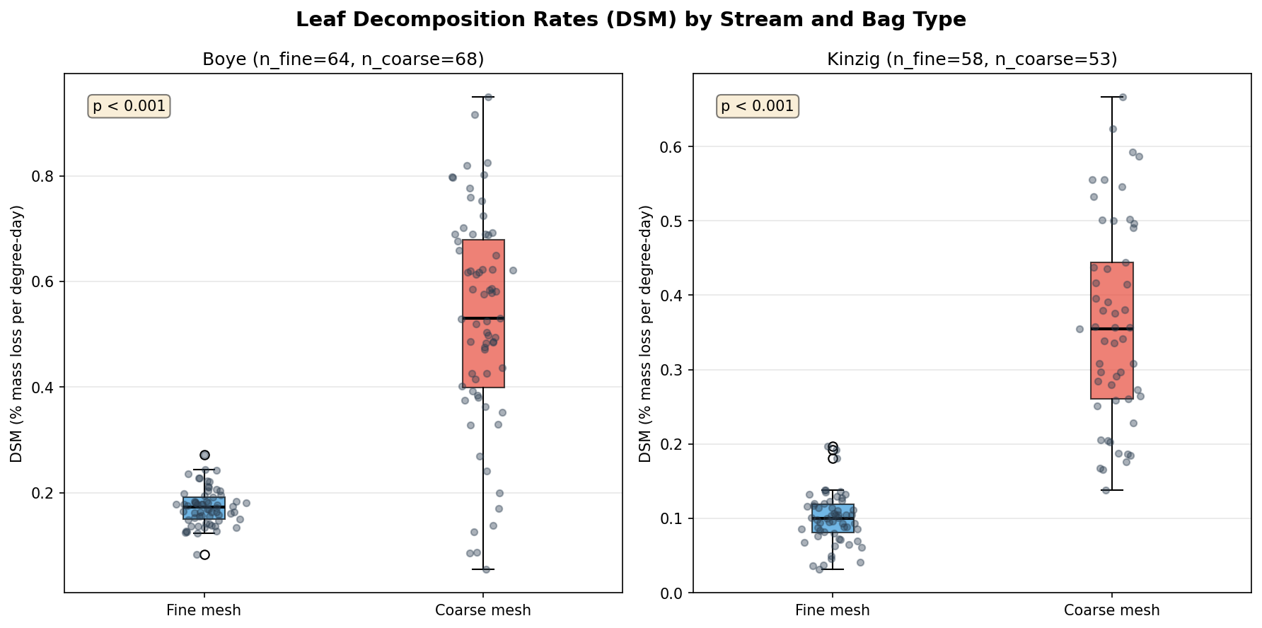
Figure 1. Boxplot of DSM values (individual leaf bags) by stream and bag type. Coarse mesh rates significantly exceed fine mesh rates in both catchments (p < 0.001).

3.2 Boye Stream — Hypothesis Test Results
Conductivity was the primary significant predictor of fine mesh decomposition in Boye (H1 supported, r = −0.459, p = 0.028, n = 20; Figure 2). Urban land use percentage was not a significant predictor (H2 not supported, r = −0.265, p = 0.247), though the negative directional trend was consistent with the hypothesis. Metal contamination did not significantly predict fine mesh DSM (H4 not supported; Zn: r = −0.025, p = 0.919; Cu: r = −0.298, p = 0.175), likely because metal concentrations remained below ecologically relevant inhibitory levels (mean Zn: 2.82 µg/L; mean Cu: 0.18 µg/L). Coarse mesh DSM was 3.04× higher than fine mesh, confirming significant shredder activity (H3 partially supported; t = 13.95, p < 0.001), though site-level Gammarus abundance did not significantly predict the magnitude of coarse mesh DSM (r = 0.075, p = 0.744).

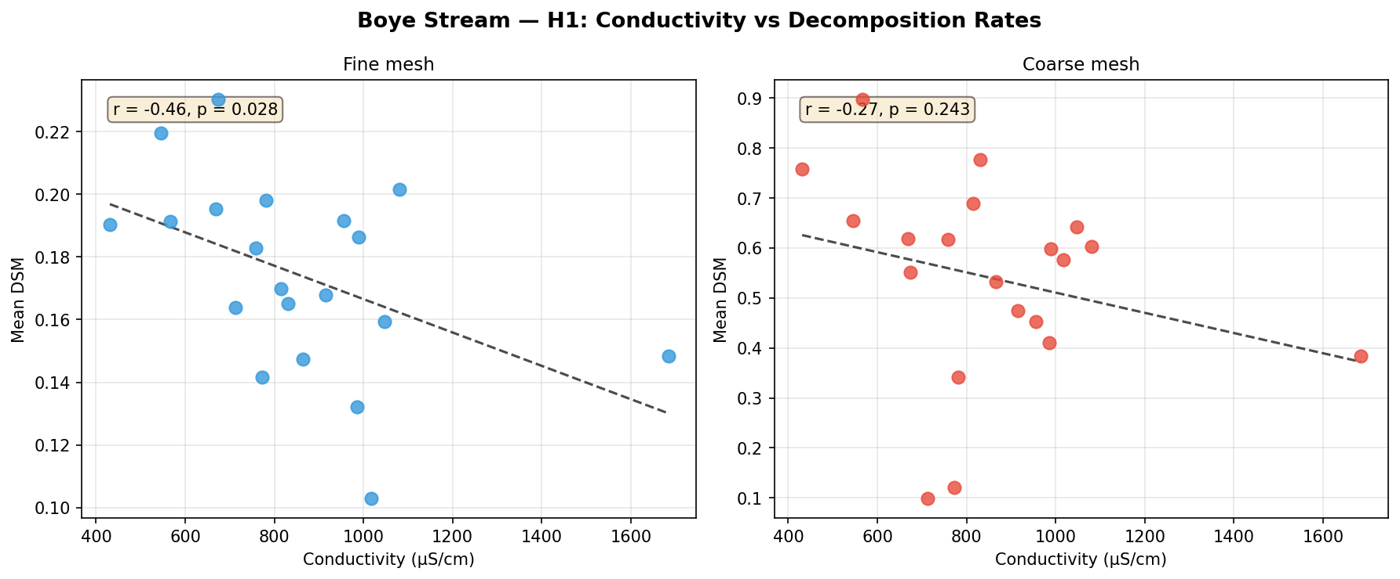
Figure 2. Conductivity vs fine mesh (left) and coarse mesh (right) DSM in Boye Stream. Significant negative relationship for fine mesh only (r = −0.459, p = 0.028).

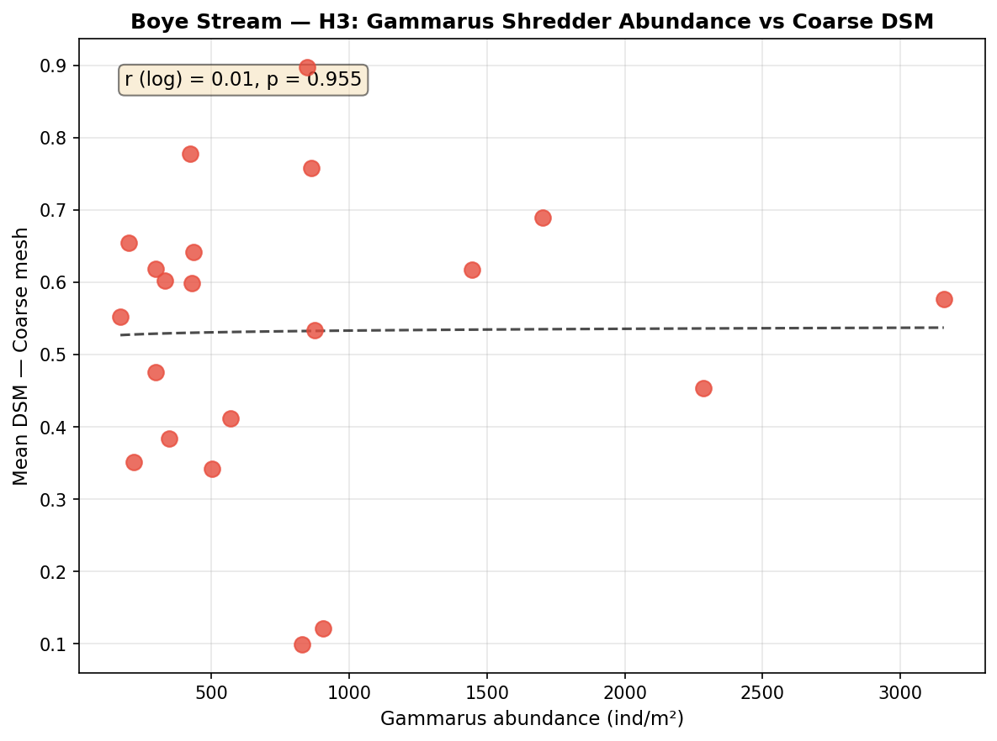
Figure 3. Log-Gammarus abundance vs coarse mesh DSM in Boye Stream. No significant site-level relationship (r = 0.075, p = 0.744), despite a 3.04× overall fine-to-coarse DSM ratio.
3.3 Kinzig Stream — Hypothesis Test Results
Agricultural land use percentage was the dominant and highly significant predictor of fine mesh DSM in Kinzig (H2 strongly supported; r = +0.738, p = 0.0002, n = 19; Figure 4). This is the strongest relationship identified across both streams. Nitrate concentration showed a positive but non-significant trend (H1 not supported; r = +0.344, p = 0.120), consistent with a nutrient-stimulation mechanism. Conductivity was not a significant predictor (H4 not supported; fine: r = +0.202, p = 0.389), though it co-varies with agricultural land use. Coarse mesh DSM was 3.62× higher than fine mesh, confirming strong shredder activity (H3 strongly supported; t = 13.60, p < 0.001).

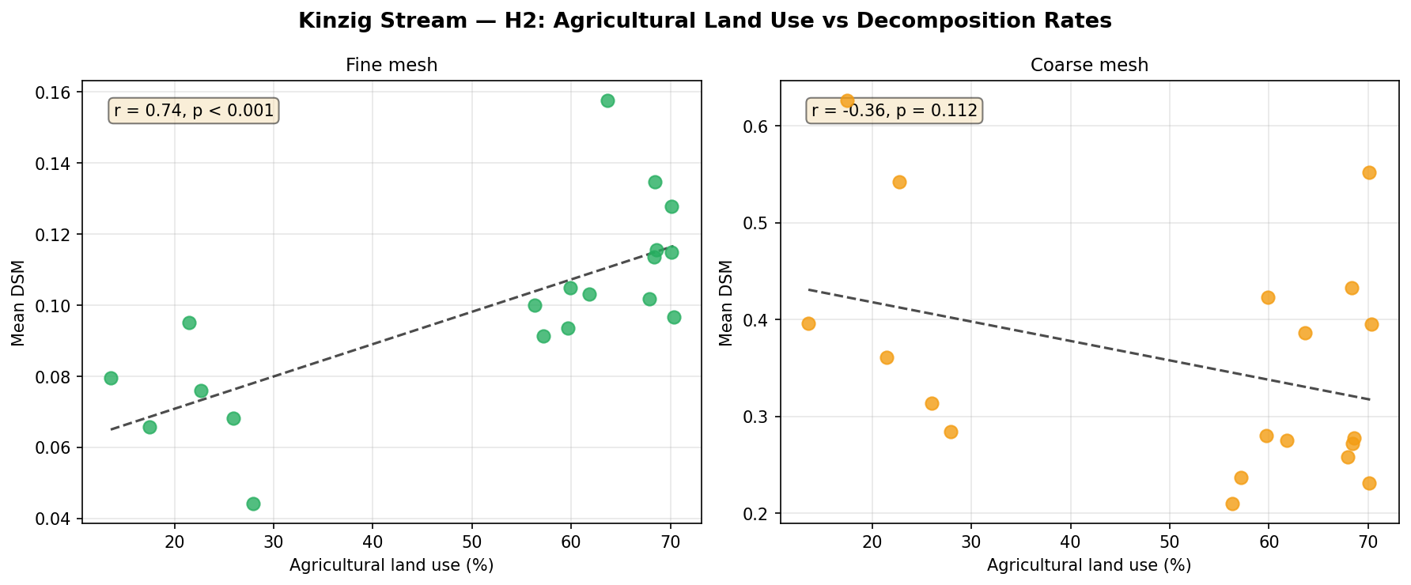
Figure 4. Agricultural land use (%) vs fine mesh (left) and coarse mesh (right) DSM in Kinzig Stream. Strong positive relationship for fine mesh (r = +0.738, p = 0.0002).

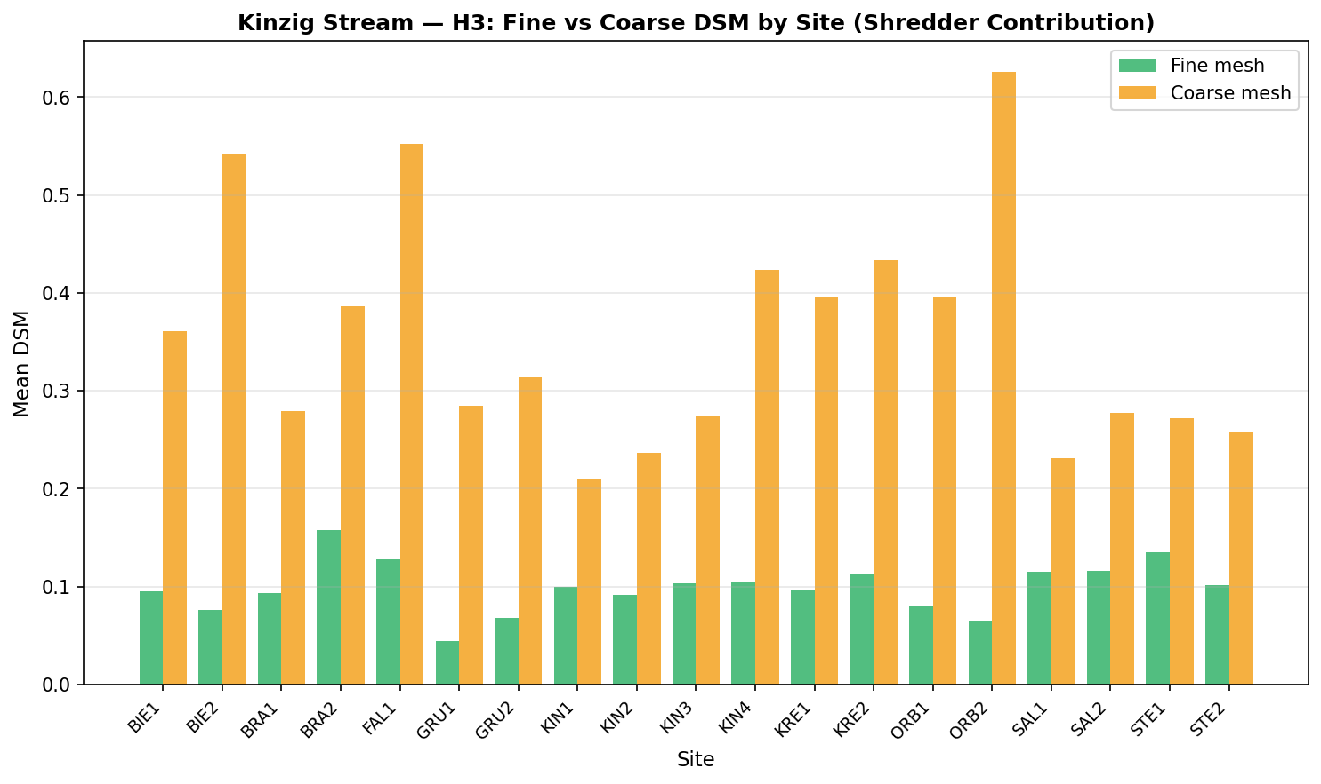
Figure 5. Fine vs coarse mesh DSM per site — Kinzig Stream. Coarse mesh DSM consistently exceeds fine mesh at all sites, confirming shredder contribution (p < 0.001).

3.4 Correlation Structure
Correlation matrices revealed contrasting structures between the two streams (Figures 6–7). In Boye, metal variables (Cd, Cu, Ni, Zn) were strongly co-correlated (r > 0.7) with each other and with conductivity, reflecting co-linear urban/industrial contamination pathways. DSM (fine) was most negatively correlated with conductivity (r = −0.46) and positively with pH (r = 0.31). In Kinzig, nutrient variables (NO₃, TN, PO₄) were strongly intercorrelated and co-varied with agricultural land use percentage (r > 0.6), confirming agricultural runoff as their primary source.

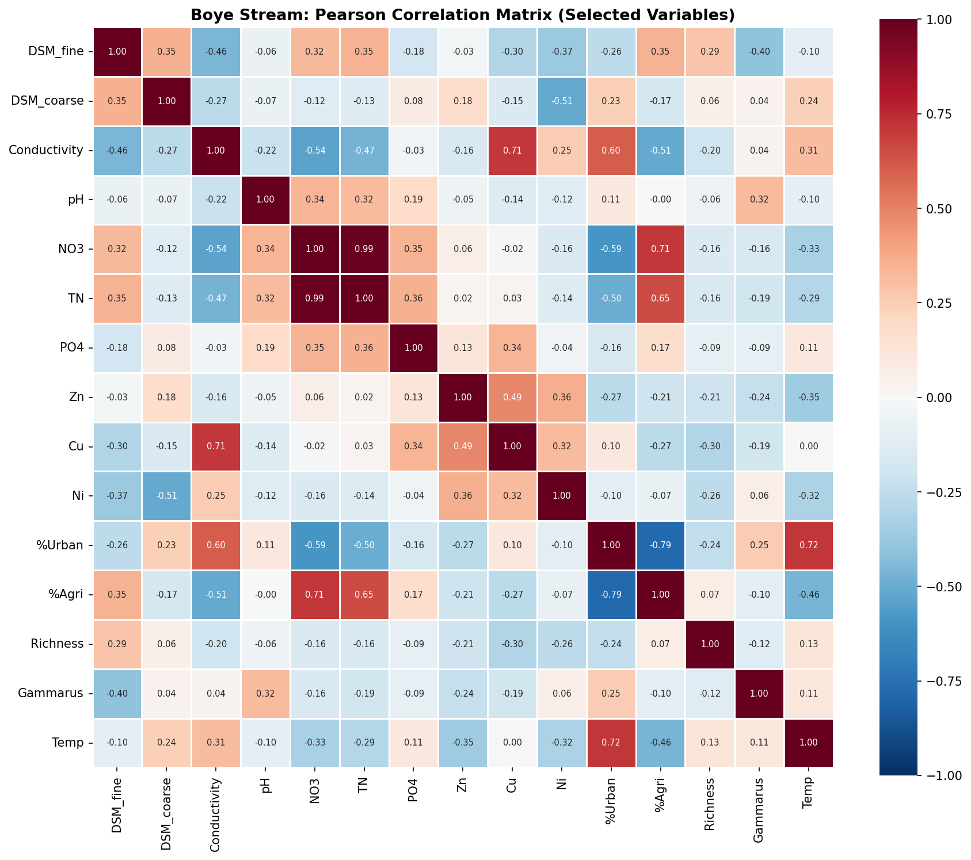
Figure 6. Pearson correlation matrix — Boye Stream. Note: DSM fine shows strongest relationship with conductivity.
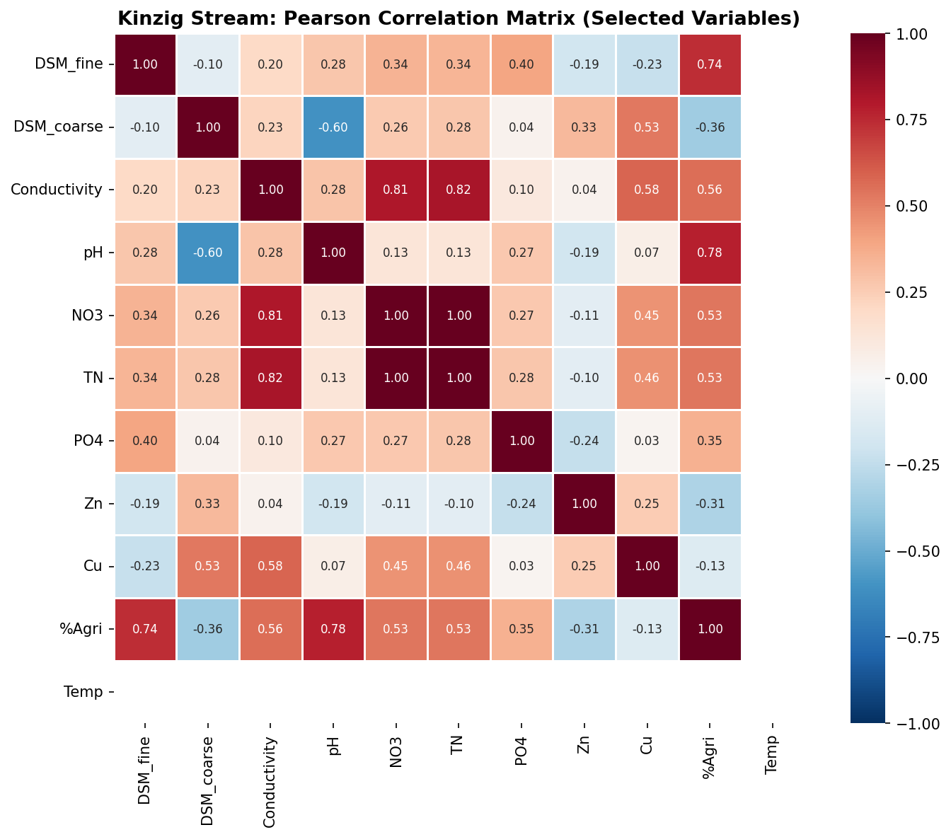
Figure 7. Pearson correlation matrix — Kinzig Stream. Agricultural land use (% Agri) co-varies strongly with nutrient variables.

4. DISCUSSION
4.1 Conductivity as a driver of microbial decomposition in urban streams
Our finding that conductivity negatively predicts fine mesh DSM in Boye (r = −0.459, p = 0.028) is consistent with the growing body of evidence that ionic contamination impairs stream ecosystem function in urbanised catchments. Electrical conductivity integrates the concentration of dissolved ions (Na⁺, Cl⁻, SO₄²⁻, K⁺, Ca²⁺, Mg²⁺) that accumulate through urban runoff, wastewater discharge, and industrial effluents. High ionic concentrations alter the osmotic environment of microbial biofilms, potentially disrupting enzymatic activity and fungal sporulation rates critical for leaf decomposition (Canhoto et al., 2013).
Interestingly, the negative trend was only observed for fine mesh bags (microbial pathway), not coarse mesh (microbial + shredder pathway). This suggests that while microbial decomposers are sensitive to ionic contamination within the observed conductivity range, macroinvertebrate shredders—particularly Gammarus spp.—may exhibit greater osmotic tolerance or alternative feeding strategies that buffer the effect of ionic stress on their leaf-processing activity.
4.2 Agricultural land use as a nutrient-decomposition enhancer in Kinzig
The highly significant positive relationship between agricultural land use and fine mesh DSM in Kinzig (r = +0.738, p = 0.0002) represents the strongest relationship found in this study and supports the nutrient-stimulation hypothesis for microbial decomposers. Agricultural land use drives elevated nitrogen (mean NO₃: 6.5 mg/L) and phosphorus inputs that stimulate aquatic hyphomycetes—the primary fungal decomposers of leaf litter in temperate streams (Gessner & Chauvet, 2002). The lack of a corresponding effect for coarse mesh bags (r = −0.359, p = 0.112) is intriguing and may reflect that shredder activity is constrained by physical habitat factors (substrate availability, current velocity) or by top-down predation pressure that varies independently of agricultural nutrient loading.
4.3 Shredder contribution across catchment types
The consistently higher coarse mesh DSM (3.04× in Boye; 3.62× in Kinzig) demonstrates that invertebrate shredders provide a substantial and ecologically critical decomposition service regardless of catchment impairment type. Even in the heavily urbanised Boye—where invertebrate diversity is reduced relative to pristine reference streams—sufficient Gammarus biomass persists to amplify decomposition rates substantially beyond purely microbial rates. This finding aligns with Spänhoff et al. (2007) who demonstrated Gammarus resilience in moderately impacted streams, and underscores the importance of maintaining functional shredder populations even under urban stressor gradients.
4.4 Metal contamination below inhibitory thresholds
The absence of a significant metal effect (Zn, Cu) on fine mesh DSM in Boye aligns with the observed metal concentrations (mean Zn: 2.82 µg/L; mean Cu: 0.18 µg/L) falling below the NOECs reported for aquatic hyphomycete communities in laboratory studies (e.g., Cu NOEC ≈ 10–50 µg/L; Zn NOEC ≈ 50–100 µg/L; Schäfer et al., 2011). This suggests that while the Boye catchment carries legacy metal contamination, its concentrations have been sufficiently diluted or attenuated to avoid direct toxicological effects on leaf decomposition under current flow conditions.
4.5 Implications and limitations
This study contributes to the understanding of stream ecosystem function under multiple stressors by demonstrating that the identity and relative importance of environmental drivers differs fundamentally between urban and agricultural catchment types. For stream management, this implies that generic multi-stressor indices may mask important context-specific effects: conductivity control may be more effective for protecting stream function in urban systems, while nitrogen management may be the priority in agricultural catchments.
Several limitations should be noted. First, the study was conducted over a single short deployment period (March 2025, ~15 days), and seasonal dynamics in both decomposition rates and environmental variables could affect findings. Second, no explicit pesticide data (e.g., sumTU indices) were available for this dataset, which limited testing of the toxic unit approach used in Schreiner et al. (2023). Third, the absence of significant Gammarus effects on coarse DSM across sites may reflect the snapshot nature of the shredder sampling rather than a true lack of functional relationship.

5. CONCLUSIONS
This study demonstrates that leaf litter decomposition rates in German streams are governed by contrasting environmental drivers depending on catchment land use context. In the urban Boye Stream, ionic contamination (conductivity) negatively constrains microbial decomposition, while invertebrate shredders provide a robust, stressor-tolerant contribution to total decomposition. In the agricultural Kinzig Stream, nutrient enrichment mediated through agricultural land use strongly enhances microbial decomposition, while shredder contributions remain significant and consistent across sites. These findings underscore the need for catchment-specific approaches to stream ecosystem functional assessment, and reinforce the value of the DSM metric—normalised by thermal exposure—as a sensitive, reproducible indicator of stream ecosystem health across diverse stressor gradients.

REFERENCES
Bundschuh, M., Pierstorf, R., Schreiber, W. H., & Schulz, R. (2011). Positive effects of organic matter addition on stream macroinvertebrates. Freshwater Biology, 56(1), 135–149.
Canhoto, C., Calapez, A. R., Gonçalves, A. L., & Moreira-Santos, M. (2013). Effects of Eucalyptus leachates and salt on leaf-litter processing by fungi and stream invertebrates. Freshwater Science, 32(2), 411–424.
Gessner, M. O., & Chauvet, E. (2002). A case for using litter breakdown to assess functional stream integrity. Ecological Applications, 12(2), 498–510.
Lecerf, A., & Richardson, J. S. (2010). Biodiversity-ecosystem function research: Insights gained from streams. River Research and Applications, 26(1), 45–54.
R Core Team (2024). R: A language and environment for statistical computing. R Foundation for Statistical Computing, Vienna, Austria. https://www.R-project.org/
Schäfer, R. B., Bundschuh, M., Rouch, D. A., Szöcs, E., von der Ohe, P. C., Pettigrove, V., Schulz, R., Nugegoda, D., & Kefford, B. J. (2011). Effects of pesticide toxicity, salinity and other environmental variables on selected ecosystem functions in streams and the relevance for ecosystem services. Science of the Total Environment, 415, 69–78.
Schreiner, V. C., Feckler, A., Zubrod, J. P., Rachor, J., Knoll, S., Schäfer, R. B., & Bundschuh, M. (2023). Multiple stressors and the functioning of stream ecosystems: Towards a better integration of ecological and ecotoxicological research. Environmental Toxicology and Chemistry, 42(5), 1165–1179.
Spänhoff, B., Bischof, R., Böhme, A., Lorenz, S., Neumeister, K., Nöthlich, A., & Küsel, K. (2007). Assessing the impact of effluents from a modern wastewater treatment plant on breakdown of leaves and benthic macroinvertebrate communities in a temperate lowland river. Aquatic Conservation: Marine and Freshwater Ecosystems, 17(2), 190–209.
Woodward, G., Gessner, M. O., Giller, P. S., Gulis, V., Hladyz, S., Lecerf, A., ... & Chauvet, E. (2012). Continental-scale effects of nutrient pollution on stream ecosystem functioning. Science, 336(6087), 1438–1440.

